**

**‘A’ LEVEL’ MARKING GUIDE**

**GEOGRAPHY**

PAPER 1

*00 - totally irrelevant*

*01 - 08 Rudimentary answer i.e. a few undeveloped facts*

*09 - 11 ‘O’ level answer*

*12 - 14 basic ‘A’ level answers*

*15 - 17 A good answer*

*18 - 20 A very good answer*

*21 - 25 excellent or outstanding answer*

1. ***COMPULSORY MAP WORK QUESTION***
2. *(i) The man made feature at grid reference 539073 is a bore hole .*

*(ii) The grid reference of the water tank at Makiro is 51037*

1. *Given a new scale of 1:25,000, enlarge the area between eastings 54 and 58, and northings 10 and 13 on the map extract, and on the new frame, mark and name*

*Title = 01 mark*

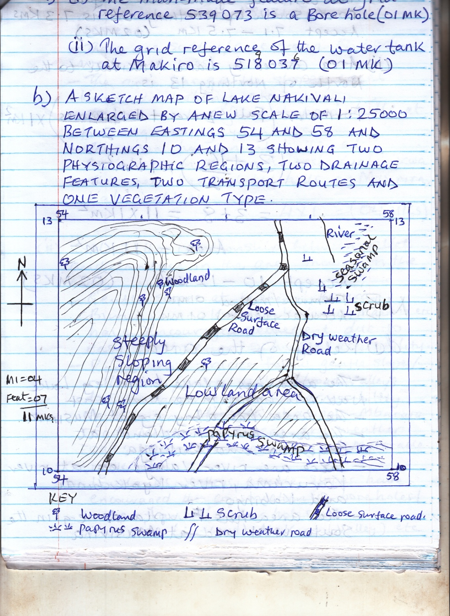

*------ motorable*

1. *(i) The distance of the loose surface road south of northing 06 is 7.3*

*kms accept 7.1 – 7.5km*

*(ii) Area covered by lakeNakivali to the north of northing 13 is;*

*Formula (full square _) x 1 km2*

*= 2*

*= 3 + 8 = 11 x 1 km2*

*Area = 11km2*

*Accept 10 - 12km2*

*NB : Formula / method 01*

*Accuracy (answer) 01*

1. *(i) Describe the relief of the area shown on the map extract.*

* *The area has a lake basin e.g lake Nakivali basin in the north east*
* *The area has a bay e.g. at Musirira*
* *The area has a head land at Buganza and Rukinga*
* *There are river valleys e.g. at river Karuruma, river kyakabindi and kabingo*
* *The area has uplands e.g. in the southwest and northwest, southwest, South East*
* *The area has ridges e.g. in the west and north west, isozi, itoma, wementi*
* *There are saddles / cols e.g. in the north west and west*
* *The areas has gentle slopes e.g. at kagando, kibengoetc*
* *The area has flat topped hills / plateauburungamo, igayazaetc*
* *The area has conical hills at omiibare in the north west, kyabirikwa*
* *The area has knols e.g. Musirira, Kahirimbi*
* *Low lands in the north east*

*4 x 1 = 4 marks*

*(ii) Explain the relationship between relief and land use in the area shown on the map. (04 marks)*

* *Gentle slopes at Bushenyi, Bizera, Burungamo, Kibingo, Mabonaetc have encouraged settlement due to easy construction of houses / accessibility*
* *Roads and tracks follow gentle slopes / ridge tops / narrow valleys / broad valleys due to easy construction / accessibility e.g. Kibwera – mabona – Kibingo - Mbarara road; Musirira – bizera dry weather road; ngarama - Kajurungusimotorable track etc*
* *Low lands, valleys, gentle slopes have encouraged the construction of boreholes, water tanks / water holes at Musirrira (low land) makiro (valley) etc*
* *Steep slopes near mabona in the west have favoured forestry due to limited human interfereces*

*Any 2 x 2 = 4 marks*

*Total 25 marks*

1. *A LANDSCAPE SKETCH OF THE AREA SHOWN ON THE PHOTOGRAPH SHOWING CLIFF, MEANDER LOOP, FLOOD PLAIN, OXBOW LAKE*

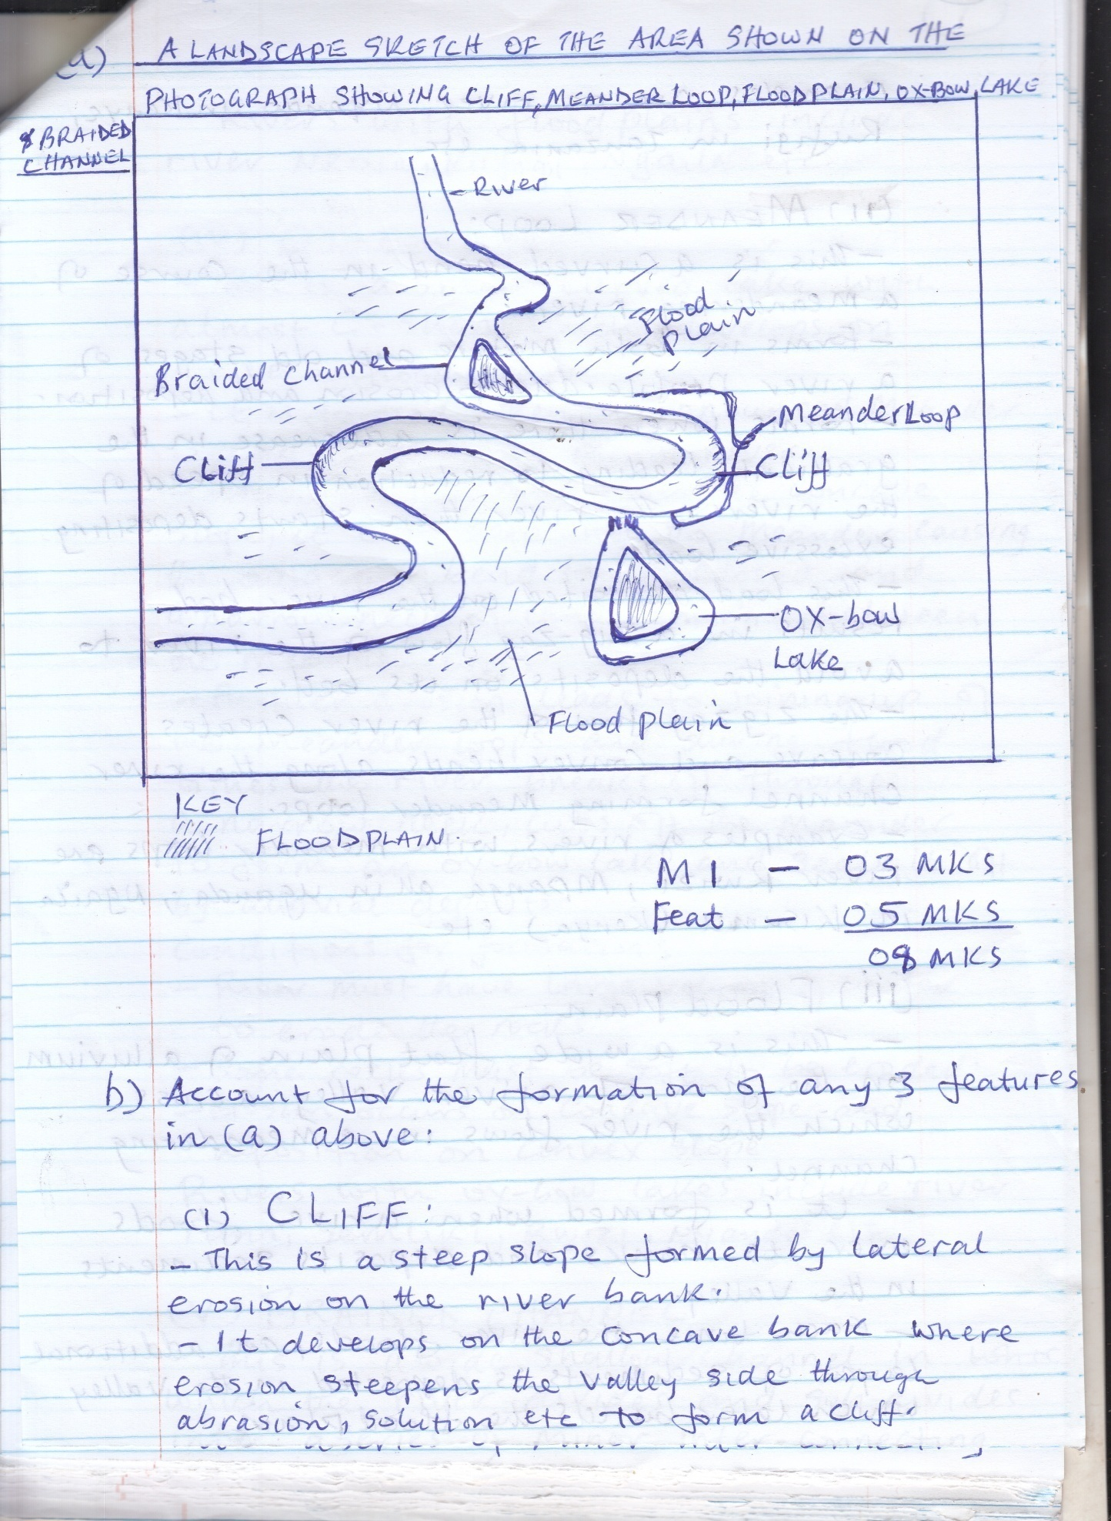

*M1 - 03 marks = title, frame, labeling*

*Feat - 05 marks*

*= 8 marks*

1. *Account for the formation of any three drainage features in (a) above.*

*(09 marks)*

1. *OX – BOW LAKE*

* *This is a small curved lake with almost C – shape which develops on a river’s flood plain*
* *It is formed when a pronounced meander is cut off from the main river*
* *When erosion occurs on the concave slope, it cuts deep into the meander causing the adjacent bend to be closed and a narrow neck of land remains between the meander loops.*
* *Further erosion leads to joining up of the meander loops and during flood times, the river breaks off through a narrow neck, cuts off the meander to form an ox – bow lake and seals it off by alluvial deposits.*

1. *Discuss the problems likely to face the people living in the area shown in the photograph. (06 marks)*

* *Destructive flooding due to presence of flood plain (wide flat relief)*
* *Harmful pests and diseases due to floods e.g. mosquito in the marshy areas, snails from the river etc causing diseases*
* *Barrier to transport and communication routes construction due to meander braid.*
* *Accidents due to drowning of the animals in the river*

*Any 3 x 2 = 6 marks*

1. *Giving reasons for your answer, suggest one area in East Africa where this photograph could have been taken. (03 marks)*

*Areas Along river;*

* *Rwizi*
* *Nzoia*
* *Nyando*
* *Tanaetc*

***Reasons***

*Presence of;*

* *Ox – bow lake*
* *Meanders*
* *Braided channel etc*

*NB: Identification - 01 mark*

*Evidece - 02 mark*

*Total 25 marks*

***SECTION B***

1. *Examine the role of geological structure in the formation of land forms in East Africa. (25 marks)*

* *Define geological structure*
* *Explain the aspects of geological structure linking them to formation of land forms in East Africa*
* *Give illustrations*

*Geological structure refers to the physical and chemical properties or make – up rocks e.g.*

* *Hardness*
* *Softness*
* *Jointing*
* *Colour*
* *Permeability*
* *Stratification etc*

*Role of geological structure in the formation of land forms*

* *Soft country rocks are easily removed by erosion exposing intrusive rocks (batholiths) to form inselbergs e.g. Kachumbalainselbert in Bukedeaetc*
* *Differences in rock hardness leads to formation of volcanic plugs e.g. Tororo rock, soft rocks around the volcanic plug are removed by erosion leaving behind a protruding granitic rock called plug*
* *Presence of joints in the coastal rocks has influenced the development of several coastal features e.g. wave erosion through hydraulic action easily widens the cracks to form caves, geos, blow holes e.g. at Mombasa.*
* *Existence of cracks / joints in the rocks has resulted in the formation of fault – guided valleys e.g. the Awwa river valley in Northern Uganda. Areas around cracks are easily eroded to form fault – guided valleys*
* *Soluble rocks e.g. limestone have led to the formation of stalactites, stalagmites, caves, pillars in Nyakasura. These form through carbonation*
* *Hard rocks resist erosion (wave erosion ) and may project into the sea to form of headlands, cliffs etc and soft rocks dissolve to form bays*

*Etc*

*Impressional marking (25 marks)*

1. *To what extent does the rate and character of weathering depend on lithology?*

*(25 marks)*

* *Define weathering*
* *Bring out lithology / nature of the rock influence on the rate and character of weathering*
* *Bring out other factors which influence the rate and character of weathering*

*Weathering refers to the process of physical distintegration and chemical decomposition of rocks in situ by natural agents at or near the earth’s surface.*

*To a larger / smaller extent the rate and character of weathering depends on lithology:-*

* *Mineral composition. Basic igneous and metamorphic rocks when exposed on to the earth’s surface are highly affected by chemical weathering at a fast rate because they were formed under temperature and pressure conditions very different from those on the earth’s surface.*
* *Sedimentary rocks on the other hand are more stable than igneous rocks and metamorphic rocks, chemical weathering may however affect rocks with iron compounds through oxidation process*
* *Rock hardness. Hard rocks e.g. quartz are more resistant to weathering than soft ones e.g. clay hence soft rocks break at a faster rate than hard rocks*
* *Rock clour;. Dark coloured rocks e.g. granite absorb a lot of heat and are therefore easily weathered by exfoliation, block disintegration or granular disintegration.*
* *On the other hand bright and shining rocks e.g. obsidian reflect much of the heat / light hence weather wat a slower rate.*
* *Rock jointing / fracturing. Jointed rocks e.g. limestone disintegrate faster than rocks without joints. This is because the joints / cracks allow entry of water and air into the interior of the rock leading to increase in the rate of chemical decomposition of the rock leading increase in the rate of chemical decomposition of the rock through hydration, hydrolyssetc*
* *Jointed rocks also attract physical weathering process of freeze and thaw as water freezes in the cracks / joints and later melts*
* *Jointed rocks also allow plant roots to penetrate into the rocks leading to chemical weathering through chelation as well as mechanical weathering of the rock at a faster rate e.g. block disintegration*

*However, the rate and character of weathering also depends on other factors:-*

* *Climate. Variations in climate lead to different rates and character of weathering*
* *Equatorial climate accelerates chemical weathering process e.g. hydration, hydrolysis due to heavy rainfall and hot temperatures*
* *Equatorial climate also limits physical weathering due to the thick layer of chemically weathered materials which tend to protect or cover the underlying rocks*
* *Savana climate characterized by wet and dry seasons influences both physical and chemical weathering processes.*
* *During the dry season the high diurnal ranges result into exfoliation and block disintegration processes of physical weathering*
* *While in the wet season chemical weathering dominates through processes e.g. carbonation, oxidation etc*
* *In arid and semi – arid clmate e.g. Karamoja, Chalbi desert (Kenya) etc physical weathering processes such as exfoliation, block disintegration dominate due to high diurnal range*
* *In montane climate for example on glaciated mountains i.e. Rwenzori, Kilimanjaro, Kenya, Physical weathering through freeze and thaw dominates*
* *Relief. Steep slopes encourage faster rate of weathering particulally physical weathering processes like freeze and thaw. This is because on steep slopes weathered materials are quickly removed and underlying rock is exposed.*
* *Gentle and flat slopes accelerate the rate of chemical weathering processes e.g. hydration, solution. This is because this kind of relief has high water retention capacity required for chemical weathering*
* *The gentle and flat slope also tend to have thick layer of soil and vegetation reducing the rate of physical weathering. This is because accumulation of overlying weathered rocks block underlying rocks.*
* *Valleys generally have slow rate of weathering due to impeded drainage. Some valleys are constantly cold and covered by water and vegetation. Such conditions lower the rate of both physical and chemical weathering.*
* *Influence of plant and animals. Decomposed dead plants and animals accelerate the rate of chemical weathering processes e.g. carbonation. This is because these dead plants and animals release compounds e.g. carbons, ammonia which react with water to form acids like carbonic acid, ammonic acid. These acids react with rocks e.g. limestone, dolomite leading to chemical weathering.*
* *Burrowing animals e.g. rodents, termites etc facilitate both physical and chemical weathering processes. Physically, these animals break the rocks through drilling channels (physical weathering)*
* *The drilled channels allow in oxygen leading to oxidation processes (Chemical weathering) iron rocks absorb water which percolates down these channels hence chemical weathering through hydration*
* *Thick vegetation cover slows down the rate of physical weathering. This is because the trees protect the underlying rocks against the sun’s insolation limiting exfoliation etc*
* *Man emits industrial gases leading to acid rains (carbonic acid) which accelerate chemical weathering through carbonation*
* *Man also dumps industrial waste on land and in water increasing acidity in the environment hence chemical weathering*
* *Man carries out mining, quarrying, cultivation which lead to break down of rocks leading to physical weathering such activities also expose rocks to chemical weathering.*
* *Time ; the longer the period of exposure of rocks to weathering processes, the deeper the disintegration and decomposition and vice versa*

*Evaluation (2 marks)*

*Content = 23 marks*

*25 marks*

1. *With reference to specific examples from East Africa, describe the landforms*

*produced by marine erosion. (25 marks)*

* *Define waves*
* *Describe processes of marine erosion*
* *Identify and describe land forms due to marine erosion.*
* *Examples / illustrations required.*

*Waves are ripples or oscillations on the surface of a water body. They are caused by winds blowing over the water surface creating friction between the water and the wind. The energy is then transferred from the wind to the water to form waves which move along in the direction of the wind. Waves carry out marine erosion in the seas, oceans and lakes*

*Marine erosion occurs through a number of processes;*

* *Hydraulic action. This process involves the waves sending powerful swashes that pound against the cliff face. When water hits jointed cliff face, air is compressed within the craals and suddenly expands causing shock waves that break coastal rocks.*
* *Abrasion (corrosion). This process involves waves using the material they are carrying e.g. pebbles, boulders, sand etc as a grinding tool against the shoreline / coastline such materials hurled against coastal rocks led to marine erosion.*
* *Attrition. This process occurs when the eroded rock fragments and pebbles carried by the waves knock against themselves and become smaller hence get easily eroded.*
* *Corrosion / solution. This p process occurs along limestone coastlines. Soluble rocks e.g. limestone dissolve in water leading to formation of marine erosional features.*

*The processes above have resulted in the formation of marine erosional landforms which include;*

* *Cliff. This is a vertical / steep rock face found at the high tide level of the coast.*
* *It is formed when waves hit the coast and cut a small notch on the coastland through hydraulic action, abrasion or corrosion.*
* *Repeated wave action causes the notch to enlarge forming a steep face*
* *Retreat of the sea may expose the steep face as a cliff.*
* *Examples of cliff are at Fort Jesus in Mombasa, Kasenyi in Entebbe etc*

***Illustration / diagram)***

* *Wave cut platform. This is a bench like coastal feature sloping towards the sea below the cliff.*
* *It forms between high tide and low tide.*
* *It is formed as a result of abrasion and hydraulic action under cutting the base of a cliff to retreat backwards forming a bench like structure at its base called wave cut platform. Examples are at Tiwi beach at Dar – es – Salaam; south of Mombasa in Kenya etc*

***Illustration or diagram***

* *Cave. This is a cylindrical tunnel drilled through a cliff. It is wide at the entrance and Narrow at the end. Forms on jointed rock. The wave swash and backwash movement cause abrasion and hydraulic action compressing the trapped air in the joints.*
* *As the waves retreat the trapped air suddenly expands and exerts pressure within the joints or cracks breaking up the rocks to form a cave.   
  examples of caves are found at Entebbe palm resort beach, Lutembe, Tiwi and Kitifi, Kasenyi.*

***Illustration / diagram***

* *Blow hole. This is a vertical shaft or opening extending to the top of the earth’s surface. It is formed when hydraulic action within the caves creates great pressure which may open up hollows especially through cracks along the roof of a cave forming blow holes*

*Examples are at Malindi. Lesourffer blow hole south of Renuinon, Kasenyi landing site.*

***Illustration / diagram***

* *Geo : this is a narrow steep – sided inlet along a cliff. It is formed when hydraulic action leads to collapse of the entire roof of a cave. Before the formation of a geo, a blow is usually formed at the end of the cave and this is followed by the collapse of the entire roof of the cave forming a geo.*

***Illustration / diagram***

* *Bays and headlands.*

*A bay is a wide extension of the sea or lake into land. Bays are formed in areas of alternating soft and hard rocks around the coast. Soft rocks are eroded by solution or abrasion using strong swash and backwash movement of waves.*

*Examples of bays include Kavironde gulf (Hoima) Karunga bay (Kenya) Mombasa, Watamu, Malindi, Tanga*

*Headlands are generally hard rocks or a piece of land protruding or extending into the sea. They are formed in areas of alternating soft and hard rocks in that soft rocks are eroded away while hard rocks resists marine erosion and remain protruding into the sea.*

*Examples of headlands include Entebbe peninsula, Mweya peninsula and Kasenyi, headland along lake Victoria.*

***Illustration or diagram***  *]*

* *Stack. This is an isolated rock structure which has been completely detached from the main land / head land. It is formed when wave erosion through abrasion removes the arch which eventually collapses into the sea leaving a piece of head land detached from the main land called stack. Examples are at Malindi and Mombasa.*

***Illustration or diagram***

* *Stump. This is a residual rock worn down to the level of the water (sea) or below water or sea level by marine erosion. It is formed when waves erode the stack reducing it to level below water surface. Examples at Kasenyi.*
* *Arch. This is a bridge like featue found above caves. It is formed when a cave is driven into the side of a headland and ultimately opens out on the other side. It can also form when 2 caves develop from both sides of the head land and eventually meet creating a passage through the headland.*

***Illustration / diagrams***

*Impressional marking (25 marks)*

***SECTION C***

1. *(a) Distinguish between frontal rainfall and orographic rainfall. (10 marks)*

*Definition*

*Explanation of formation*

*Illustration*

* *Frontal rainfall is also known as cyclonic rainfall. It is the type of rainfall that ours when air masses of different characteristics in terms of humidity and temperature meet.*
* *The warm moist air mass is light and therefore rises on top of the cold air mass. As the warm air mass rises, it undergoes adiabatic cooling until it forms cumulo nimbus clouds which later fall as rainfall.*

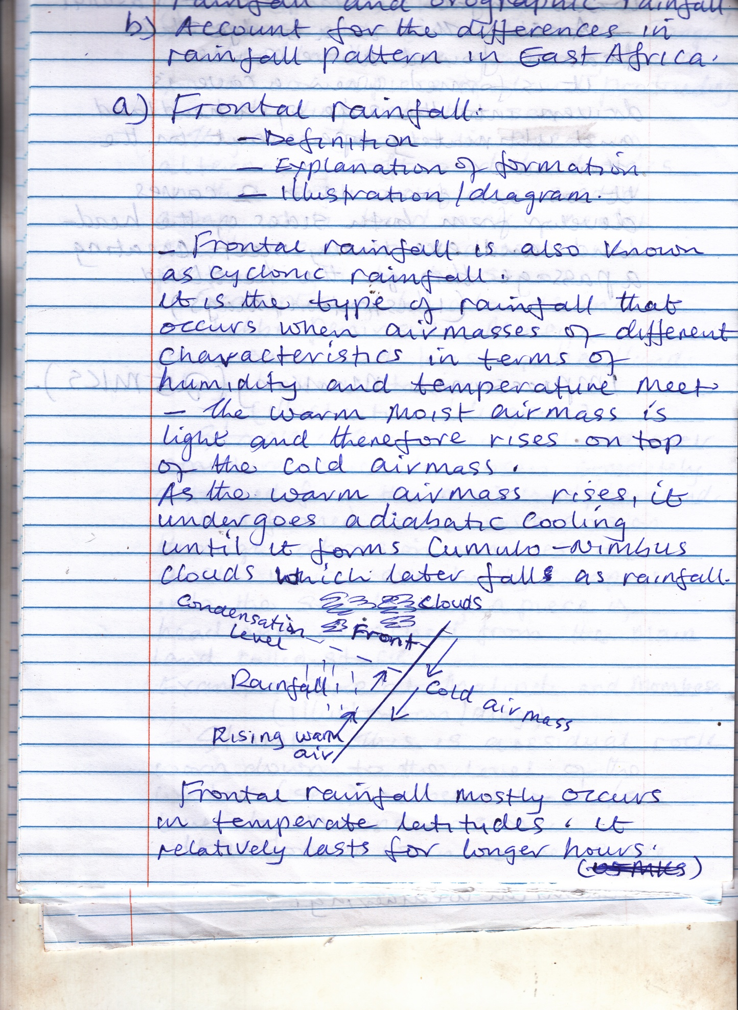

* *Frontal rainfall mostly occurs in temperate latitudes. It relatively lasts for longer hours in the tropical regions e.g. East Africa such rains are heavy and last for a short period of time. It is associated with hailstone and strong winds.*

***While***

***Orographic rainfall***

* *This is the type of rainfall formed when warm moist rising air meets a relief barrier e.g. mountain, hill or highland.*
* *It is most common where moist air or wind rises over a mountain barrier on the windward side.*
* *As it ascends, it cools down adiabatically at the condensation level at an average rate of 1oC per 100m forming cumulo – nimbus clouds.*
* *The wind ward side of the mountain therefore receives much more rainfall*
* *On the lee ward of the mountain there is descending dry wind, hence little or no rainfall is received.*
* *This type of rainfall is common in mountainous areas or highlands of kilimajaro, Rwenzori, Kenya etc*

***Illustration or diagram***

*(b) Account for the differences in the rainfall pattern in East Africa.*

*(15 marks)*

*Identify and describe rainfall pattern or distribution in East Africa*

*Explain reasons for the rainfall pattern.*

*Rainfall pattern / distribution in East Africa is not uniform – some areas have high rainfall while others have moderate or low rainfall.*

* *High rainfall is found in the high land areas e.g. slopes of mountain Elgon, Kilimanjaro, and Kenya, lake Victoria basin e.g. Lugazi, Entebbe, Kisumu, Bukoba.*
* *Moderate rainfall is found in western, central and some parts of northern Uganda e.g. Lira and Gulu, southern Tanzania, western Tanzania e.g. around Mbeya, and Kenya it is found in Kisumu, Eldoret, Nanyuki*
* *Low rainfall is found in Northern Kenya e.g. Chalbi desert, Turkana land, north eastern Uganda e.g. Kotido, Kabong districts, western and eastern rift valley areas, Ankole – Masaka corridor, central Tanzania*

***Reasons for the differences in rainfall pattern in East Afria are;***

* *Influence of inter tropical convergence zone.*
* *This is a low pressure zone that follows the apparent movement of the sun. it is associated with heavy rainfall and hot temperatures above 240C. Areas around the equator e.g. Entebbe, Jinja have higher rainfall than distant areas e.g. Kabong. This is because the sun is over head twice at the equator hence two rainfall seasons*
* *Altitude. Areas at high altitude e.g mountain Kilimanjaro, Elgon have higher rainfall. This is because mountainous areas constantly receive orographic rainfall on the wind ward side.*
* *Presence of water bodies. Areas adjacent to water bodies e.g. Victoria basin at Jinja in Uganda receive convectional rainfall as a result of evaporation hence higher rainfall than areas distant from water bodies and influence land and sea breeze*
* *Vegetation. Regions with thick vegetation in form of forests e.g. kakamega, kissi, in Kenya, mabira in Uganda have higher mean annual rainfall amounts. This is because through evapo – transpiration, trees are able to encourage formation of convectional rainfall.*

*However, areas devoid of vegetation receive little rains resulting into variations in rainfall between the two regions.*

* *Influence of prevailing winds. The south east trade winds that emerge from south Indian ocean, carry heavy humidity ad so result into heavy rainfall around Victoria basin and Kenya highlands. For the reason, they have higher rainfall*
* *Latitudinal location. This is the equi – angular location from the equator. Areas that are astride the equator e.g. kampala, Entebbe, Kisumu have higher rainfall than those far away from the equator e.g. Turkana or central Tanzania. This is because they lie in the areas of low pressure, attracting convergence of winds hence receiving rainfall through out the year.*
* *Influence of ocean currents. The warm ocean currents raise the temperature of winds blowing over them resulting into a low pressure zone. Air or winds blow from land towards the ocean thus become off shore. This deprives the coastal area e.g. Dar – es – Salaam, Mombasa rain hence low rainfall amounts. On the contrary, islands in the Indian Ocean e.g. Zanzibar receive heavy rainfall*
* *Human activities e.g. bush burning, deforestation, and swamp reclamation have affected rainfall formation particularly in northern Uganda and Kenya. This has resulted into low rainfall in those regions than in the south where such activities are minimum.*

*Impression marking (15 marks)*

*Total (25 marks)*

1. *Account for the distribution of natural forest vegetation in East Africa.*

*(25 marks)*

*Define natural forest*

*Identify types of natural forest vegetation in East Africa giving areas where each is found.*

*Give characteristics of each type of natural forest vegetation*

*Explain factors for distribution of each type.*

*natural forest vegetation refers to forests which exist in a given place in their natural form without human interference.*

*Natural forest vegetation includes:*

* *Tropical rainforest. This is the type of forest vegetation growing largely around the equator e.g. around lake Victoria basin i.e. mabira, budongo, bugoma, semliki in Uganda; gongeni, kiisi, Kisumu, kakamega in Kenya, Bukoba, Mpanda in Tanzania*

***Characteristics***

* *Tall trees up to 60 metres and above due to competition for sunlight*
* *Trees consist of hard wood species i.e. Mvule, Mahogany, Musizietc due to long gestation period.*
* *Trees are ever green, shedding off their leaves at different intervals because of constant rainfall hence continuous growth of trees.*
* *Trees form dense canopies usually in 3 layers due to growth of trees at different intervals*
* *The forest has little or no undergrowth due to the thick canopies preventing light from reaching the ground.*
* *Trees have broad leaves to allow evaporation and transpiration to occur and get rid of excess water*
* *Trees grow in mixed stands i.e numerous species e.g. mvule, mahogany etc due to ample water supply*
* *Trees have numerous climbing plants like lianas, epiphytes that get support from the tall and huge trees.*
* *Trees have straight and big trunks due to ample water supply and nutreints*
* *Most trees have buttress roots to give them support to the huge and tall trees or trunks*
* *Trees have long gestation period i.e. take long to mature e.g. 60 years and above*

***Mangrove forests or vegetation***

* *These are wet land vegetation found along the coastal areas of Kenya and Tanzania especially in esturaries and bays at the mouths of river pangani, rufigi, Ruvuma, tanaetc*

***Characteristics***

* *Mangrove trees have aerial roots for respiration*
* *Trees have green leaves i.e. ever green due to availability of enough water throughout the year.*
* *Trees have broad leaves to get rid of excess water*
* *Trees have dense - bushy stands because of hot and wet conditions and ample supply of nutrients.*
* *Trees grow in mixed stands i.e. have various species e.g. red mangrove*
* *Trees are of hard wood since they grow in the tropics i.e. hot and wet conditions*
* *Trees have medium height of about 30 metres high due to ample supply of rainfall*
* *Trees have medium height of about 30 metres high due to ample supply of rainfall*
* *Trees have short stumpy trunks in low tidal waters*

***Montane forests***

* *These are forest vegetations found on mountains or highlands e.g. mountain Kenya, Kilimanjaro, rwenzori.*

*They include;*

*Temperate forests*

*These are montane forests found at an altitude of between 2500 – 3500m*

*Characteristics*

* *Trees are soft wood trees e.g. pine*
* *Trees are ever green*
* *Trees have small leaves i.e. needle shaped*
* *Trees are conical in shape*
* *Trees have no under growth*
* *Species include camphor, podocarp, cedar etc*

***Bamboo forest vegetation***

* *These are montane forest vegetations found between altitudinal range of 3500 – 4000m above sea level*

*Characteristics*

* *Trees have small tough pointed leaves.*
* *Trees have segmented stems that are hollow*
* *Trees have prop roots*
* *Trees appear in a single layer*

***Factors for distribution***

* *Climate*
* *Tropical rainforests grow in humid and hot conditions e.g. around lake Victoria where rainfall is over 1500mm per annum, well distributed through out the year and where temperatures are high about 27oC and above through out the year. This favours the growth of very tall trees like Mahogany.*
* *Mountain forests particularly temperate forests grow under cool and wet conditions in highland areas e.g. mountain Elgon, Kilimanjaro etc making trees be ever green.*

***Altitude***

* *Tropical rainforests grow well in areas of low altitude e.g. around Lake Victoria basin with forests like mabira. This is because such low altitude areas encourage deposition of fertile soils which are well drained favouring growth of luxuriant trees.*
* *Bamboo and temperate forest grow in high altitude areas e.g. on the upper slopes of mountain Elgon, Kilimanjaro because such areas have cool temperature and moderate rainfall for the growth of ever green trees.*

***Drainage***

* *Most of the forests e.g. equatorial, bamboo and temperate forests grow in areas that are well drained or in areas with moderate drainage e.g. around lake Victoria hence the growth of huge trees in mabira forest*
* *Mangrove forests grow in poorly drained areas (water logged areas) e.g. along east African coast*

***Soils***

* *Tropical rain forests do well in areas with deep fertile soils which facilitate the growth of huge luxuriant trees e.g. in mabira forest.*
* *Alluvial soils favour the growth of mangrove or riverine forests.*

***Human factors***

* *Human activities e.g. agriculture have reduced equatorial forests e.g. butamira forests Jinja was completely destroyed to grow sugar cane under kakirasugar plantation.*
* *Government policy of gazetting or conserving, bugoma forests*

***Biotic factors***

* *E.g. wild animals have reduced the formerly equatorial forests e.g. elephants, giraffes feed on the forests, reducing them to woodland or grassland.*
* *Wild animals also disperse tree seeds leading to expansion of natural forests e.g. mabira, budongo.*

*Impresional marking*

*(25 marks)*

1. *To what extent is the development of latosols influenced by climate?*

*(25 marks)*

* *Define latosols*
* *Describe formation and identify areas of occurrence*
* *Take stand point*
* *Explain role or influence of climate*
* *Bring out other factors.*

***Latosols are red or brown*** *residual deposits or soils created from the weathering of rocks under humid and tropical conditions such soils consist of either iron or aluminium oxides and are found either in soft clays, hard pans, (duricrusts) or as a horizontal layer of granules.*

* *In East Africa latosols are found on flat topped hills of Buganda and busoga*

*Latosols are characterized by;*

* *Limited humus content due to maximum leaching*
* *They are highly porous / permeable*
* *Horizon A contains much aluminium and iron oxides*
* *They form complete soil profitesetc*

***Formation***

* *Latosols form due to excesive rainfall and hot temperatures which bring about decay and intense weathering of rocks.*
* *Silica, present in the rcks is removed by wateradn transferred from Horizon A to horizon B of the soil profile through leaching and eluviation.*
* *Iron and aluminium compounds which are insoluble remain concentrated in horizon A giving it a reddish brown colour*
* *When temperature rises the iron and aluminium compounds on the surface of the soil profile fuse together and harden to form a hard layer or pan called uricrust or may remain in the presence of surface water to form soft clays called bauvite.*

*Duricrust is thus latosoil*

*Take stand point (larger / smaller extent)*

*Role or influence of climate*

* *Rainfall. This provides water which is the basis for leaching and eluviation of soluble minerals e.g. silica leaving behind insoluble compounds of aluminium and iron oxides*
* *Hot temperature help in the fr formation of latosols. This is because hot temperatures increase the rate of chemical reactions e.g. it aids in the evaporation of water transporting deposits of iron and aluminium oxides to the surface.*
* *Hot temperatures also keep in the drying and fusing particles into duricrusts in horizon A*
* *However, there are other factors that influence the development of latosols. These include;*
* *Relief; latosols form under cnditions of low and gentle relief. Such relief allows percolations of water and leaching of horizon A and deposition in horizon B leaving behind insoluble iron and aluminiu compounds to form latosols.*
* *Nature of parent rock. Latosol form in areas where rocks contain aluminium and iron as insoluble compounds and silica and magnesium as soluble compound that are leached downwards.*
* *Drainage. LAtosols form in well drained areas that allow leaching and chemical weathering*
* *Vegetation; Availablity of vegetation (forests) facilitates the formation of latosols. This is because vegetation helps hold the soil and allow weathering to occur.*
* *Human activities. The formation of latosols is interrupted by human activities e.g. quarying, construction.*
* *Time. Latosols require a long geological period of time to allow the formation of oxides e.g. many latosols in east Africa were formed during the tertiary weathering period.*

*Ev = 2*

*Content = 23*

*Imprestional marking = 25 marks*

***END***